Rome to Stockbridge Grid Antenna Test 07/08/2019

Test 1 (Area Scan):
The Spectrum Analyzer (Anritsu MS2720T) was wired into the grid mounted antenna to scan for existing frequencies that are being used for transmitting between 1 and 6 GHz. The frequencies being used were:
- 1.9 GHz
- 2.1 GHz
- 2.3 GHz
- 2.6 GHz
- 5.2 GHz
- 5.6 GHz

At 5.23 and 5.67 GHz, the channel power was very low and at certain moments could not be seen. Below are captures of the spectrum showing the occupied frequencies.

Entire Spectrum from 1-6 GHz:
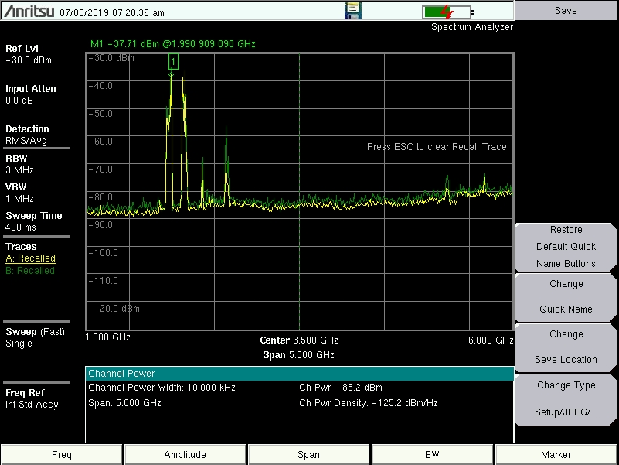

Spectrum from 1-3 GHz:
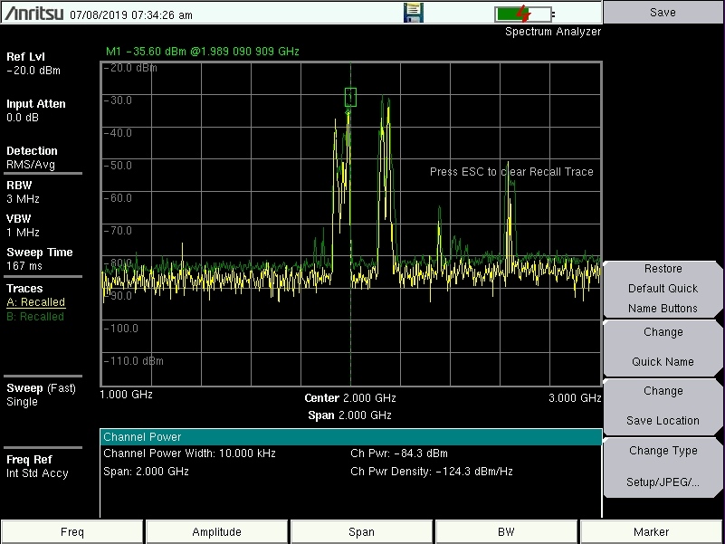

Spectrum from 4-6 GHz:
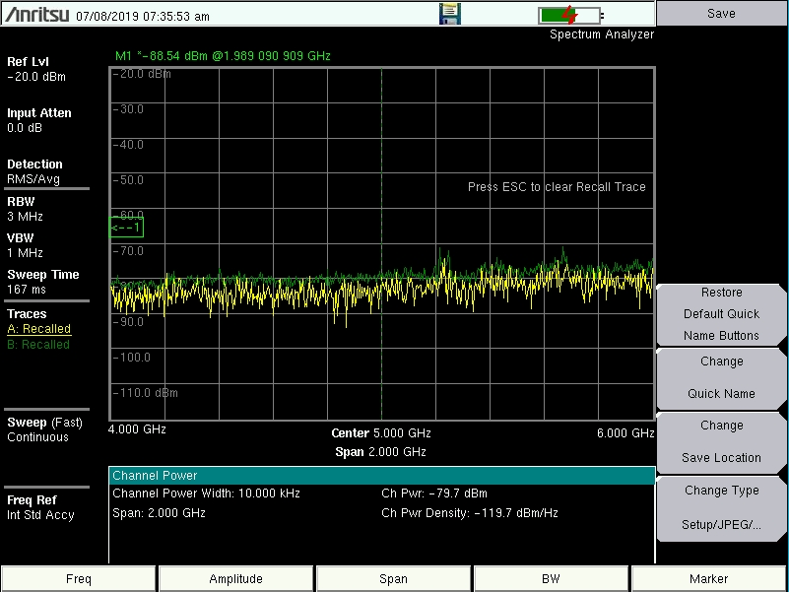

Test 2 (Signal generator + 3W Amplifier):
The signal generator + 3W amplifier was set up and wired to the grid mounted antenna at Stockbridge. The spectrum analyzer (Anritsu MS2720T) was wired to the grid mounted antenna at Rome. The test was carried out over two frequencies:
- 2.5 GHz
- 4.8 GHz
There were two variations of the test:
- From grid antenna (Stockbridge) to grid antenna (Rome)
- From grid antenna (Stockbridge) to Omnidirectional antenna on spectrum analyzer (Rome)

Grid antenna to Grid antenna at 2.5 GHz:
- Power in from signal generator: 0 dBm
- Channel power: -57.1 dBm
- Span: 20 kHz

Spectrum with center frequency at 2.5 GHz:
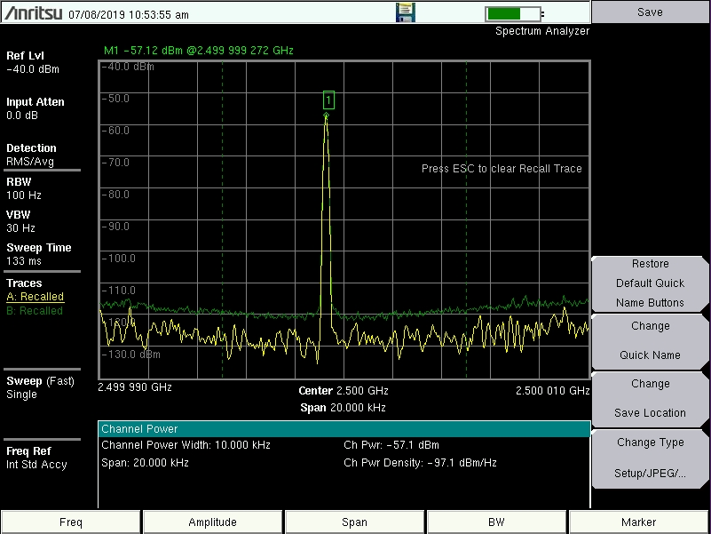

Grid antenna to Grid antenna at 4.8 GHz:
- Power in from signal generator: 0 dBm
- Channel power: -68.3 dBm
- Span: 20 kHz

Spectrum with center frequency at 4.8 GHz:
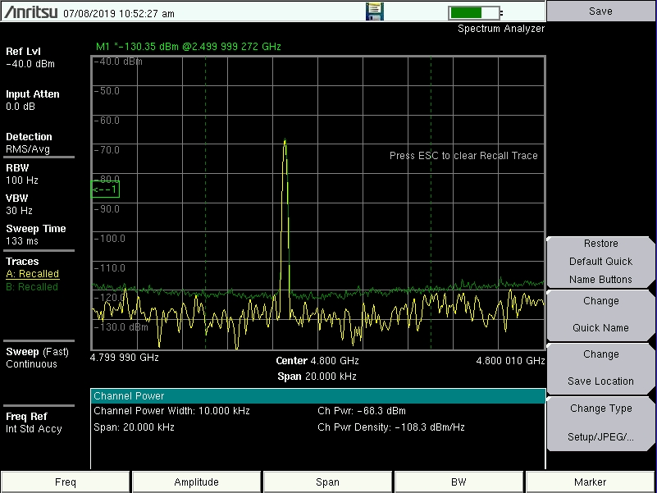

Grid antenna to Omni antenna at 2.5 GHz:
- Power in from signal generator: 0 dBm
- Channel power: -76.2 dBm
- Span: 20 kHz

Spectrum with center frequency at 2.5 GHz:
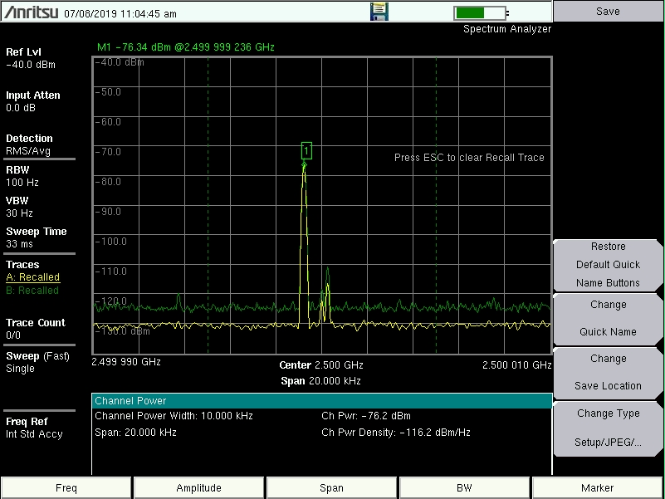

Grid antenna to Grid antenna at 4.8 GHz:
- Power in from signal generator: 0 dBm
- Channel power: -85.4 dBm
- Span: 20 kHz

Spectrum with center frequency at 4.8 GHz:
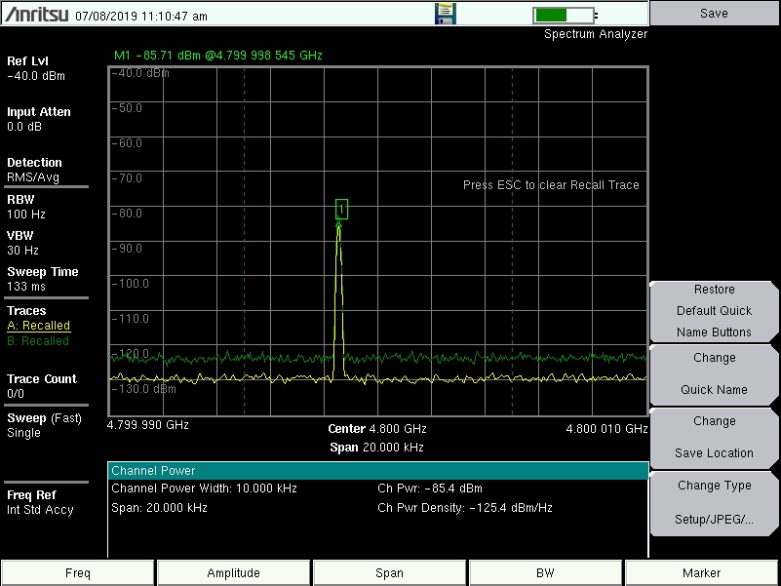
Test 3 (PaccL):
Two PaccL’s were set up and wired to the grid mounted antenna; one at Stockbridge and one at Rome. The PaccL firmware was used (by typing the IP address of the PaccL into a web browser after they are connected) to determine signal strength.

PaccL setup:
- PaccL IP 192.168.88.100 set up at Stockbridge
- PaccL IP 192.168.88.101 set up at Rome
- TX/RX on single channel (full duplex)
Test variations:
- Grid antenna (Stockbridge) to grid antenna (Rome)
- Grid antenna (Stockbridge) to Omni antenna on the PaccL (Rome)

Grid antenna to grid antenna:
- Channel power max: -80 dBm

Grid antenna to omni antenna:
- No signal detected

PaccL firmware:
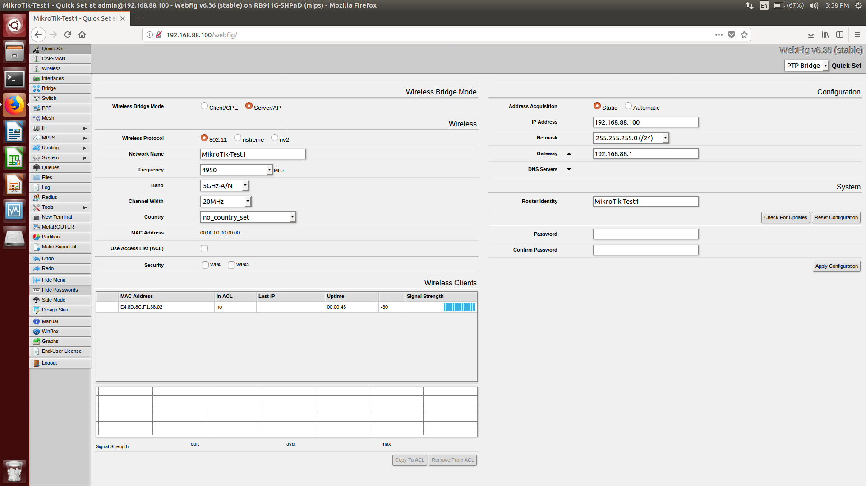

Grid antenna mounted at Rome:
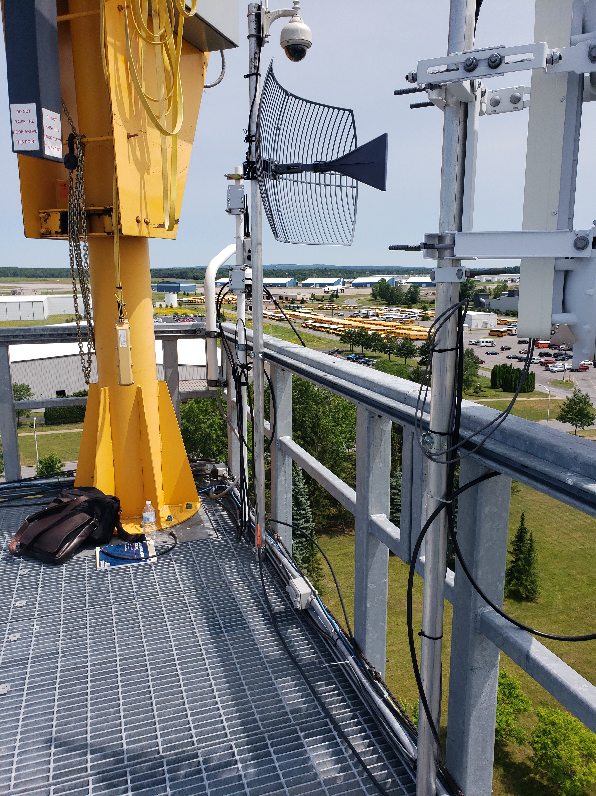
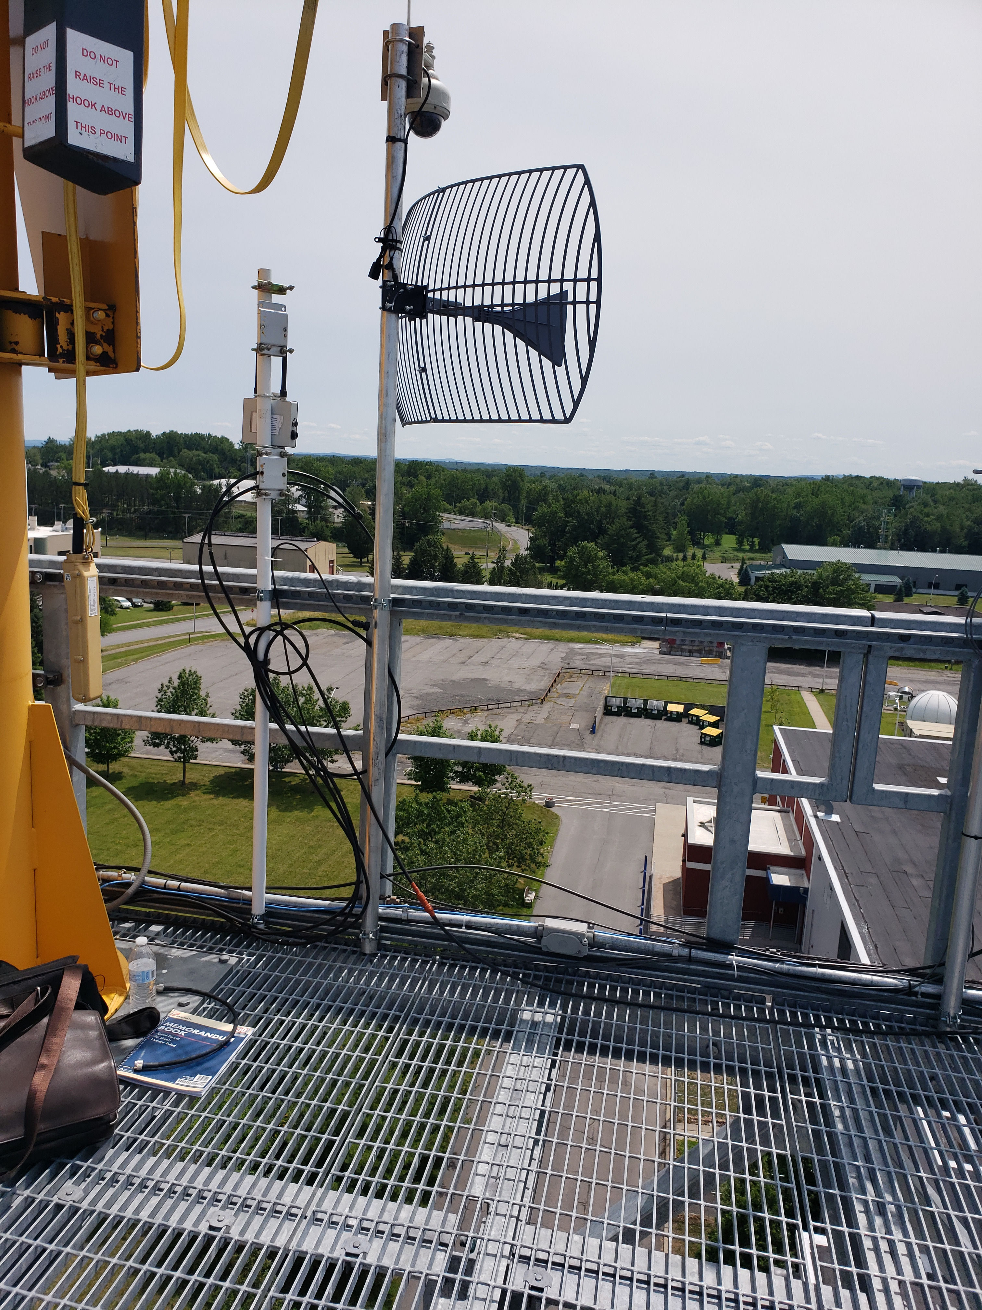

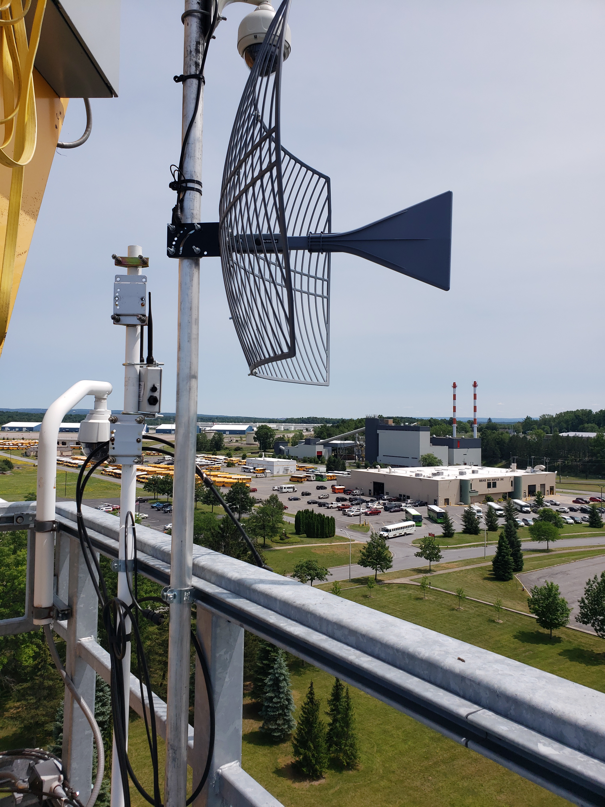

Grid antenna mounted at Stockbridge:


